Podcast Main Page and Individual Podcast Episode Page Structure
https://quantaltech.ai/
Note: Please add the podcast videos to the Podcast section under Resources. Ensure that videos are properly embedded and displayed correctly.

Section 1 - Hero Banner

Left side:

Breadcrumb: Home / Podcast
Podcast name as H1: AI Podcast for Business Leaders
Short description below H1:
Welcome to the Quantal AI Podcast where we sit down with CEOs, founders, and operators who are moving beyond AI experimentation and actually deploying AI that delivers real business results. No hype, no theoretical frameworks. Just honest conversations about what it really takes to build and scale AI-powered businesses. A must-listen AI business podcast for leaders who want actionable insights, not empty promises.
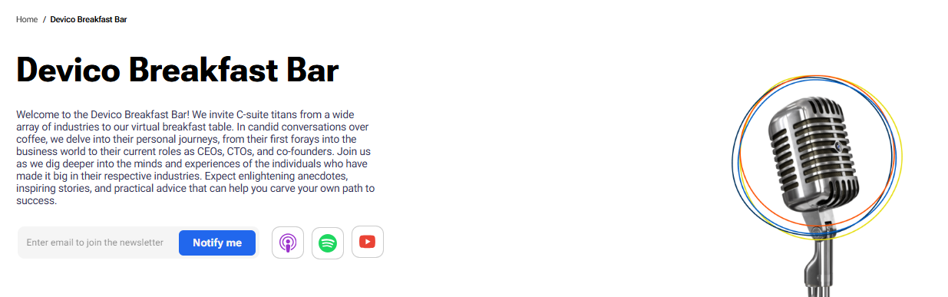
Note:- We would suggest adding Spotify if its available
YouTube subscribe button linking to https://www.youtube.com/@QuantaltechAI

Right side:
Microphone or podcast themed image. Check the image below for your reference
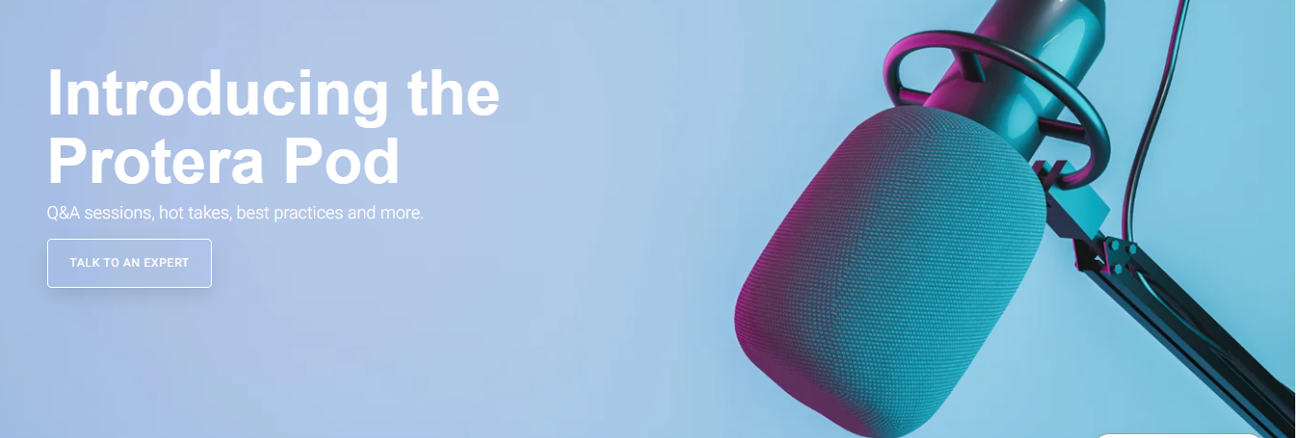
Section 2 - Featured Episode
Display the most recent episode as a featured card with:
- YouTube video thumbnail as background
- Label: "FEATURED EPISODE"
- Episode title
- Host/guest name and designation
- Play button clicking opens YouTube video in a modal or new tab
- Publish date

Episode: -
URL:- https://youtu.be/yRPHK1dXLbA?si=EuhtsDqmt-4lskd8

Image for reference: -
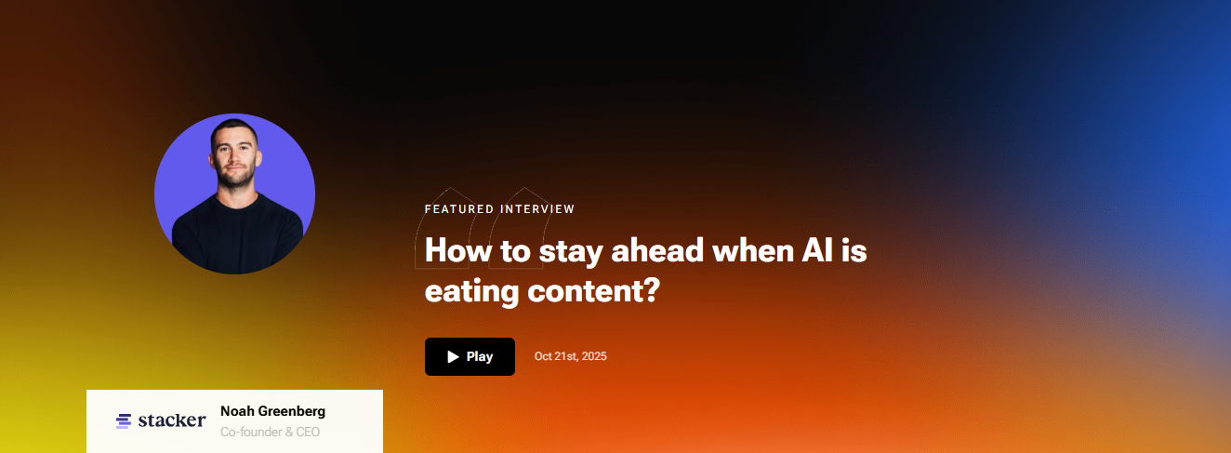
Thank you for tuning in. We are just getting started with more founders, operators, and AI builders joining us soon. Stay tuned for new episodes as we continue exploring what it really takes to build AI-powered businesses that deliver real results.

Section 3 - All Episodes Grid
Heading: "Watch All Episodes"
Display all episodes as cards in a 4-column grid. Each card contains:
- YouTube thumbnail image
- Guest name and designation
- Episode title
- Publish date
- Play button - opens YouTube in modal or new tab
Currently 2 episodes grid will expand as more episodes are added.
Here are the YouTube links -
https://youtu.be/yRPHK1dXLbA?si=EuhtsDqmt-4lskd8
https://youtu.be/p9XVKiCoYrU?si=8emiMRzmTLPgx87a
Section 4 - Final CTA
Headline: Turn Your AI Vision Into a Production-Ready Reality
Subtext:
Our team helps businesses move beyond AI exploration and build systems that deliver real, measurable outcomes. Let's talk about what that looks like for you."
- Form fields:
- First Name
- Last Name
- Company Name
- Email Address
- Message
- Submit button
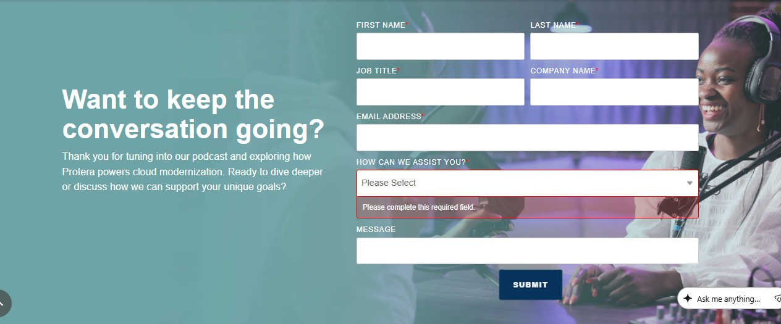

Individual Podcast Episode Page Structure
Episode 1
URL format: https://quantaltech.ai/podcast/roger-hoffmann
Section 1 - Breadcrumb
Home / Podcast / How to Use AI as a Thinking Partner and not a Replacement
Section 2 - Episode Hero
H1: How to Use AI as a Thinking Partner and not a Replacement
Below H1:
Guest Name: - Roger Hoffman
Guest designation - Founder of Coherent Systems
Publish date: - April 29,2026
YouTube subscribe button - https://www.youtube.com/@QuantaltechAI
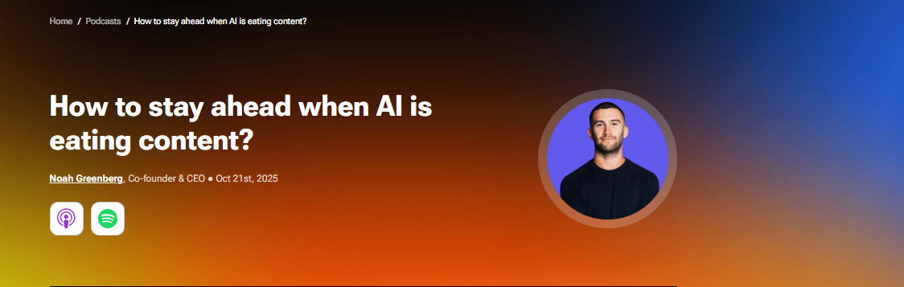
Section 3 - Embedded YouTube Video
Full width embedded YouTube video directly below the guest details. No autoplay. Lazy loaded for page speed.
Link:- https://youtu.be/yRPHK1dXLbA?si=EuhtsDqmt-4lskd8

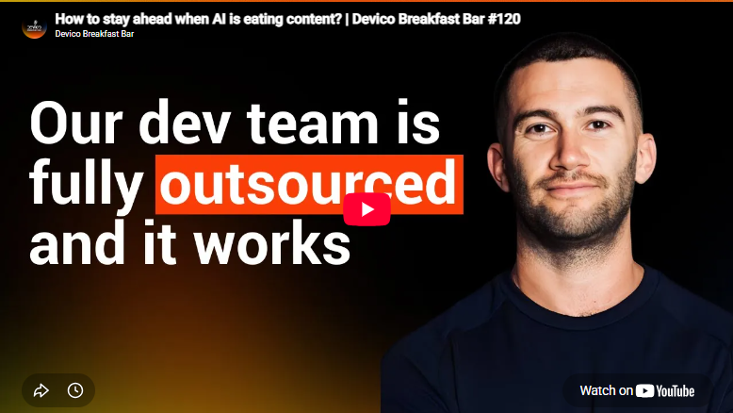
Key Takeaways
- Burnout is not a sign of weakness; it is a signal of misalignment. Roger burned out after 30 years in corporate IT and rebuilt his thinking from scratch using permaculture principles and philosophy, which now form the foundation of his business.
- AI works best as a thinking partner, not a decision maker. Roger instructs his Claude agent to challenge his assumptions, flag errors in his reasoning, and seek disconfirming information, not simply validate whatever he brings to it.
- Setting up AI correctly from day one changes everything. Roger gives his AI agent a name, a persona, a set of core values, and specific guardrails at the start of every session, treating it like onboarding a new team member rather than using a search engine.
- Optimizing for efficiency before defining effectiveness is the biggest mistake businesses make with AI. You have to know what good looks like before you try to do it faster.
- AI is an amplifier; it will amplify good thinking and bad thinking equally. If you feed it broken logic or unverified facts, it will confidently march you in the wrong direction.
Section 4 - Episode Description
In this episode of the Quantal AI Podcast, we sit down with Roger Hoffman, founder of Coherent Systems Group, a coherence consultancy and venture studio based in Arizona. Roger brings over three decades of IT leadership experience, including serving as Global CTO managing 900 people, before burning out and retreating to 40 acres of off-grid desert land to rebuild his thinking from the ground up.
Roger shares how that journey led him to develop Coherence Theory, why he considers Claude his primary thinking partner, and what he believes most business leaders are getting dangerously wrong about AI adoption.
Section 5 - Episode Highlights
H2: Episode Highlights
- How burnout after 30 years in corporate IT led Roger to a philosophy that now drives his entire business
- Why Roger gives his AI agent a name, a persona, and a set of values and what happens when you do not
- The workflow Roger built using Claude, Obsidian, and Cowork to run his entire professional life
- The biggest mistake businesses make when adopting AI and why efficiency is the wrong thing to optimise for first
- Roger's closing message on why ignoring AI is itself a choice and why coherence, not perfection, is the right governing principle

Section 6 - Watch More Episodes
H2: Watch More Episodes
Grid of 4-episode cards showing other available episodes. Each card contains:
- Guest name and designation
- Episode title
- Publish date
- Company logo
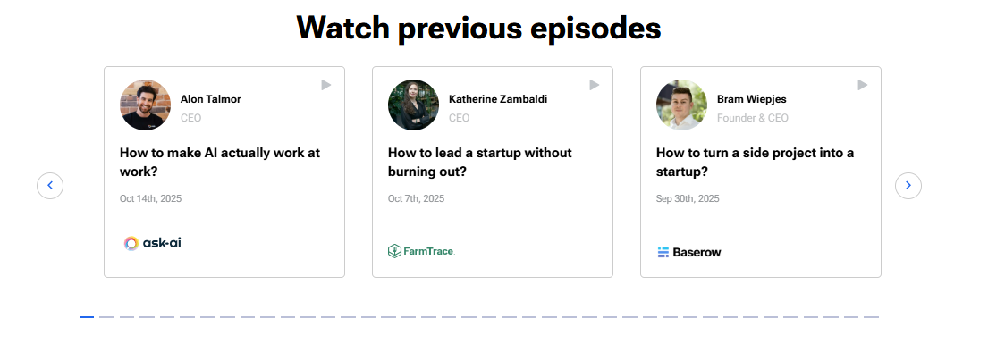
Section 7 - Final CTA
Same CTA as the main podcast page:
Headline: Turn Your AI Vision Into a Production-Ready Reality
Subtext:
Our team helps businesses move beyond AI exploration and build systems that deliver real, measurable outcomes. Let's talk about what that looks like for you."
- Form fields:
- First Name
- Last Name
- Company Name
- Email Address
- Message
- Submit button

Episode 2
URL format: https://quantaltech.ai/podcast/mike-wolford
Section 1 - Breadcrumb
Home / Podcast / How AI Workflows Outperform Agents in ROI and The Surprising Truth
Section 2 - Episode Hero
H1: How AI Workflows Outperform Agents in ROI, The Surprising Truth
Below H1:
Guest Name: - Mike Wolford
Guest designation - Founder of Lex Duo and Generative Sales Pro
Publish date: - Jun 17, 2026
YouTube subscribe button - https://www.youtube.com/@QuantaltechAI
Section 3 - Embedded YouTube Video
Full width embedded YouTube video directly below the guest details. No autoplay. Lazy loaded for page speed.
Link: - https://youtu.be/p9XVKiCoYrU?si=8emiMRzmTLPgx87a

Key Takeaways
- AI workflows and AI agents solve different problems, workflows automate repeatable step-by-step processes while agents operate as free actors given a goal and the tools to achieve it independently.
- AI outperforms human recruiters on outbound response rates; LinkedIn data shows AI-written personalised outreach consistently beats mass human messaging because it reads every post, comment, and profile before writing.
- You do not need to be a software engineer to build AI-powered apps; Mike built a sourcing application in a weekend that replaced two hours of daily research work, completing the same process in two minutes.
- The future of every profession is not doing the work; it is knowing enough about the work to grade what AI produces. Domain expertise becomes the most valuable skill you can have.
- We are moving from a digital Stone Age to a digital Bronze Age, AI has already produced more content this week than all of human history combined, and humanoid robots arriving in the next one to two years will fundamentally change what it means to work.
Section 4 - Episode Description
In this episode of the Quantal AI Podcast, we sit down with Mike Wolford, founder of Lex Duo and Generative Sales Pro, author of five books including The AI Recruiter and The Recruiter 2.0, and a 20-year recruiting veteran who has spent the last three years building AI-powered tools and workflows for businesses across recruiting and sales.
Mike breaks down the practical difference between AI workflows and AI agents, shares how he built a sourcing application in a single weekend that replaced two hours of daily research work, and explains why he believes AI outperforms human recruiters on outbound response rates. He also makes a compelling case for why the future of every profession is not doing the work itself but knowing enough to evaluate what AI produces.
Section 5 - Episode Highlights
H2: Episode Highlights
- The clearest explanation of the difference between AI workflows and AI agents and why workflows are actually the fastest path to ROI for most businesses right now
- Why LinkedIn's own data shows AI outperforms humans on recruiter outreach and what most recruiters are doing wrong that makes this gap even wider
- How Mike wrote an eight-chapter, 74,000-word book in 16 days using AI and the one thing his editor noticed that changed how he thinks about AI and voice
- The three-model setup Mike runs every day using Gemini as his business analyst, Claude as his software engineer, and Grok as his architect and why he never relies on just one model
- Why the new skill in every profession is not execution but evaluation and why Mike believes we are heading back to apprenticeships, so humans retain the expertise needed to grade AI output
- Mike's take on where AI is heading in the next two to three years humanoid robots, an AI productivity dividend, and why the real danger is not the technology but the humans who control it
- His parting message, nobody in the world has truly mastered this technology yet, and the best time to start learning is right now
Section 6 - Watch More Episodes
H2: Watch More Episodes
Grid of 4-episode cards showing other available episodes. Each card contains:
- Guest name and designation
- Episode title
- Publish date
- Company logo

Section 7 - Final CTA
Same CTA as the main podcast page:
Headline: Turn Your AI Vision Into a Production-Ready Reality
Subtext:
Our team helps businesses move beyond AI exploration and build systems that deliver real, measurable outcomes. Let's talk about what that looks like for you."
- Form fields:
- First Name
- Last Name
- Company Name
- Email Address
- Message
- Submit button

